CURRICULUM-VITAE
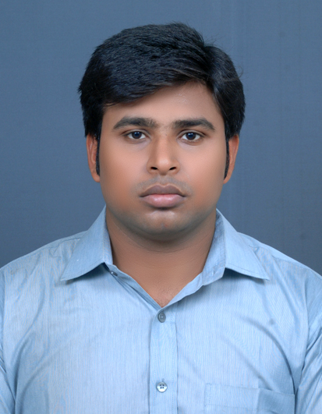
MALAY CHAKRABORTY
E-mail: malay.chakraborty.007@gmail.com
Contact No. : 9475112106 , 8017013138
Career Objective
To work in a dynamic organization for the application of managerial and interpersonal skills and enhance these skills under the guidance and supervision of the most knowledgeable and experienced elites in the field of management.

Professional Qualification
MBA[ Marketing(major) , System(minor) ]degree at MANAGEMENT INSTITUTE OF DURGAPUR . (session 2011-2013)
Academic Credentials
Name of Examination | Institute Name | Board/University | % Of Marks | DGPA | Year of passing
MBA | Management Institute of Durgapur | W.B.U.T | 63.08 | 7.13 | 2013
BCA | Gitaram Institute of Management | W.B.U.T | 73 | 8.05 | 2011
Higher Secondary (12th) | I.C.I | W.B.C.H.S.E | 64.6 | - | 2008
Secondary Education(10th) | I.C.I | W.B.B.S.E | 60 | - | 2006
Computer Proficiency
- Automation Package : Ms Office.
- Statistical Package : Ms Excel, Ms Word,Ms Power Point
WORK EXPERIENCE
- 10 MONTHS EXPERIENCE IN BENGAL BEVERAGES PVT.LTD
(Authorized bottler of the coca-cola company) as secondary sales executive.
- Presently work in Vision India Staffing Pvt. Ltd for idea cellular .ltd sciences last 5 months as a Direct Sales Team.
Extracurricular Activities & Hobbies
Hobbies & Interests : Travelling
Karate, Gym
Strengths: Leadership quality , co-operative nature , self confidence
Personal Profile
Date of Birth : 23th July, 1988.
Father’s Name : Mrinal Kanti Chakraborty
Present Address :Ramprasad Roy
c/o Malay Chakraborty
Saroda apartment,
Dr. Subodh Chandra Roy Sarani
P.O: Birati, P.S- Nimta.
Kolkata-700051.
West Bengal
Permanent Address : Vill- Pakuria, P.O - Chaltia
Pin.No-742165
P.S - Berhampore, Dist- Murshidabad
West Bengal
Gender : Male
Language Proficiency : English, Bengali, Hindi

Name of the Referees : Diptanshu Biswas.
Assistant Regional Manager in Hettich India Pvt.Ltd.
Contact No – 8585078246.
Declaration
I do hereby declare that all the particulars furnished above are true to the best of my knowledge and belief.

